MTConnect Fanuc Installation

User Guide

Draft

Thursday, March 01, 2018

# Table of Contents

Table of Contents 2

Revision History 3

FANUC SHDR INSTALLATION 3

Installation Requirements 4

Installation Steps 5

UnInstallation Steps 12

Boeing Specific Details 13

Followup 14

# Revision History

**Date Description Author Version**

|  |  |  |  |
| --- | --- | --- | --- |
| **Date** | **Description** | **Author** | **Version** |
| 1/17/2014 | Initial MTConnect Agent SDK | NIST – rough draft of MSI Windows installation for Fanuc MTConnect Adapter. Could use Ethernet or HSSB interface from Focas to CNC. Two separate MSI one for Ethernet, and one for HSSB are required. | 1.0 |
| 9/29/2015 | LAN only iseries Adapter | This describes the LAN adapter installation only. |  |

# FANUC SHDR INSTALLATION

Installing the MTConnect Agent for the Fanuc CNC, involves installing a SHDR Adapter and a MTConnect Agent with the SHDR Adapter back end (which is typical of open source MTConnect Agents). The MTConnect Fanuc Adapter generates MTConnect blessed “SHDR” text that is supported by the open source MTConnect Agent (and is easier to go thru firewalls): Example of SHDR text is:

2011-03-01T16:31:59.0617|power|ON|execution|EXECUTING|controllermode|AUTO

Note the timestamp, tags and values delimited by “|”.

This section describes installing a custom SHDR Adapter developed for Fanuc iSeries (18, 21, 30, 31 models etc) that uses a Focas DLL library to retrieve data from a compatible Fanuc CNC. The Focas library *must* match it the controller and connection, that is, the type be it 15B, 15I or iSeries and the connection, beit HSSB or Ethernet. In addition, 32 bit and 64 bit DLL possibilities are now present in Focas DLLs.

The setup is quote/unquote straightforward, as there is a MSI (Microsoft installation) program to install the SHDR adapter program. There is little configuration as this is actually confusing with all the alternative Fanuc Focas options.

NOTE it is very important that you know what Focas library is connecting to your Fanuc CNC. If you assume HSSB and its Ethernet or vice versa, IT WILL NOT WORK.

Figure 1 shows the architecture for LAN Focas MTConnect system architecture.



Figure 1 Fanuc System Architecture Focas LAN Overview

System components are:

1. CNC that must have Focas LAN Installed and running so it listens to port 8193 (32 or 64 bit immaterial).
2. FEPC: can be either 32 or 64 bit since Adapter is compiled for 32 bit and runs on 32 o 64 bit machines. The focas dll must be LAN (Ethernet). The firewall must all traffic to flow through on port 8193 and 7878 or the MTConnect adapter will not work.
3. An SHDR MTConnect Agent (preferable one that knows Fanuc tags) must run on 64 machine as MTConnect Institute agent only runs properly on 64 bit PC.
4. Client MTConnect application , such as a dashboard operates as normal, given access to the SHDR agent ip and http port to listen to: e.g., 169.254.22.252:5000 which says read PC with IP 169.254.22.252 and listen to port 5000. Port 5000 must be open on the firewall for outside clients to lisent.

## Installation Requirements

The Fanuc software installation requirements were:

1. Focas library must be installed and located in the system Path so MTConnect can gather data and then output into SHDR format. It expects this DLL in the path, and if not will fail miserably. Since Fanuc charges for the DLL it cannot be distributed with the installer.
2. Ability to install programs, possibility to increase to folder’s permissions (on Windows 7/8)
3. Ability to run MTConnect program as service. MTConnect has ability to install Adapter as service that will automically run, test for running CNC and monitor TCP connections as well.
4. How do I upgrade the MTConnect Agent service?

Stop the service. Upgrade the Exe, and the Restart the Service.

1. Make sure telnet is installed on PC. (Look up on your favorite search engine)
2. Insure that Visual C++ 10.0 CRT (x86) DLL is installed. (Should be installed with setup script). If not Download vcredist_x86.exe and install.

.

## Installation Steps

1. If Ethernet connection from Rename FanucSetupEthernet.msx to FanucSetupEthernet.msi FanucShdrStartup.msi from ftp://ftp.isd.mel.nist.gov/pub/MTConnect
2. Run MSI, and you should see an Install Wizard step. You should safely just Next, Next, … , Finish

Installation

1. Run FanucLanAdapterSetup.msi The first installation page you should see is:

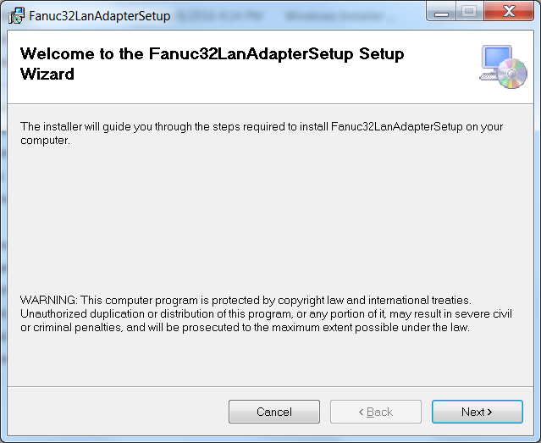

1. Ignore where to install but make sure everyone is checked:

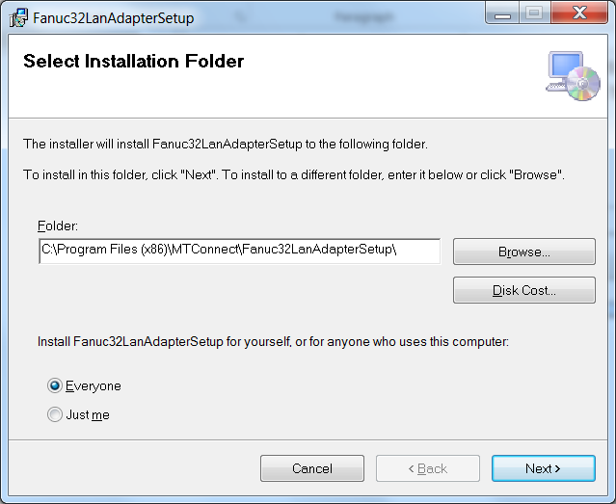

1. Configure ServiceName and IP of the CNC computer that has LAN Focas running and listening on port 8193.

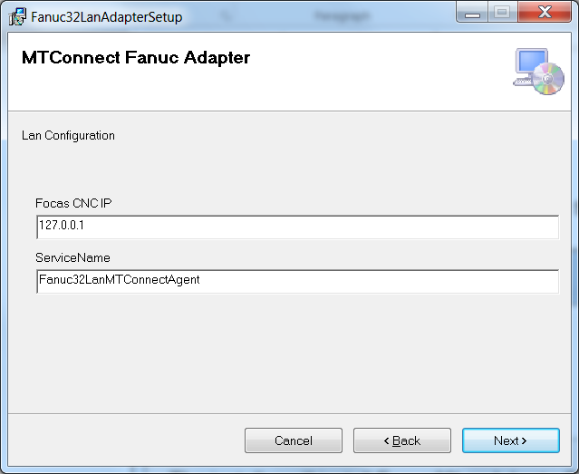

1. Almost.

### 

1. Installation of MTConnect Fanuc LANAdapter

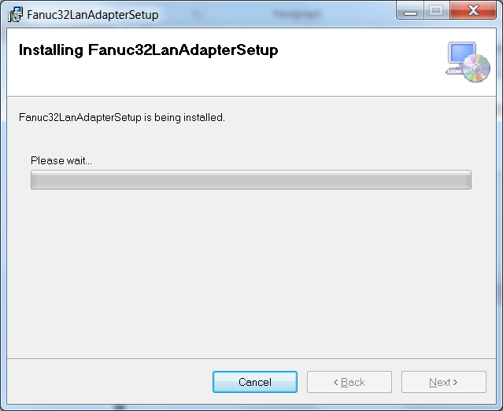

1. You must have Fanuc Focas LAN DLL installed in Windows\System32 folder:

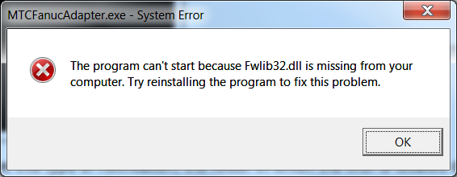

1. The final Installation Complete Dialog is issued to user. If you see the following splash screen mildly rejoice.

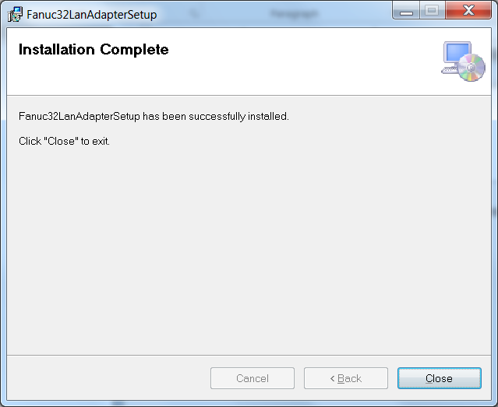

Now, you can check that the LAN agent was installed. It was installed into the C drive (if you didn’t change the installation folder C:\Program Files (x86)\MTConnect\Fanuc32LanAdapterSetup:

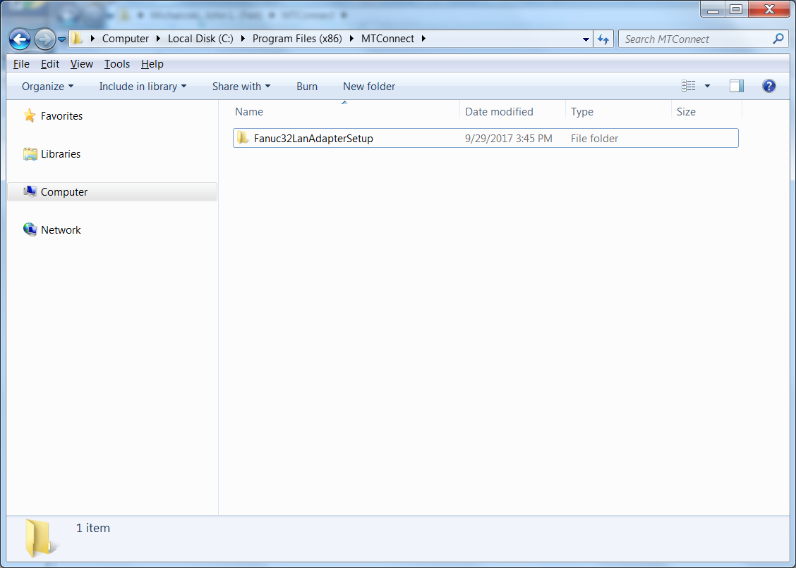

You should see the Fanuc32LanMTConnectAgent in the Service Control Manager (right click Computer icon, click Manage - you will need “admin” rights to use it). Once in computer management, select Services under “Services and Applications”. You should see the service Fanuc32LanMTConnectAgent - Automatic, but not started. Detailed explanation of the services state can found on the internet.

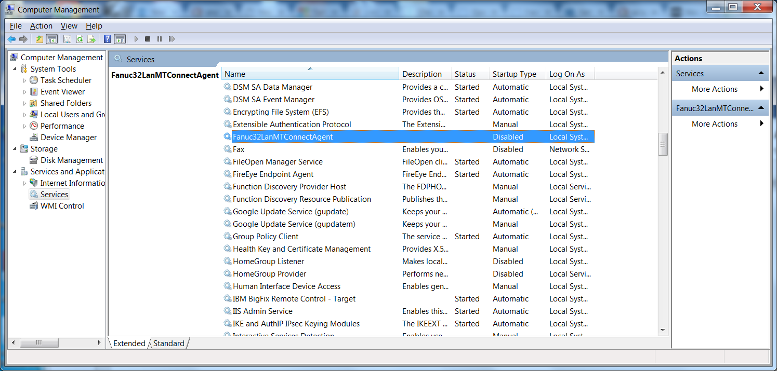

For example, if you don’t see the fwlib32.dll missing popup box, you will have to manually install the MTConnect LAN Adapter Service - MTCFanucAdapter.exe 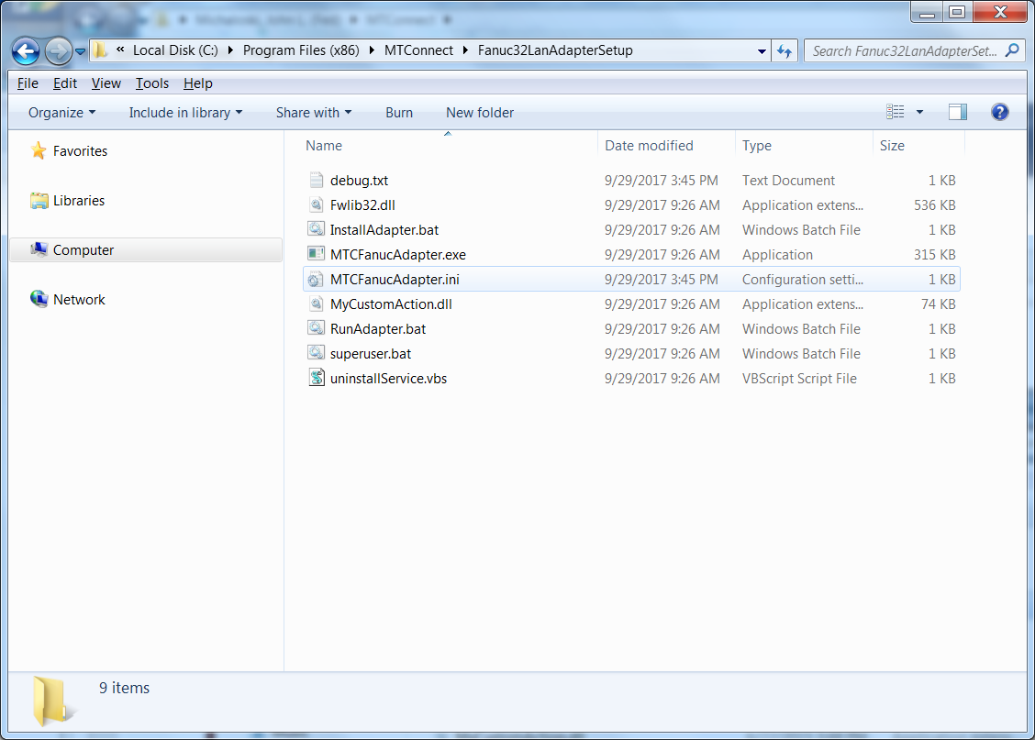

If the Service Installation of the Fanuc32LanMTConnectAgent did not happen, you will need to navigate to the installation folder (e.g., C:\Program Files (x86)\MTConnect\Fanuc32LanAdapterSetup) , (which depends on XP or Win 7 installation.) Then, UAC privileges are required to install the Adapter on you own with a batch file. Right click on “InstallAdapter.bat” and Run as Administrator (works for both Win Xp or Windows 7).

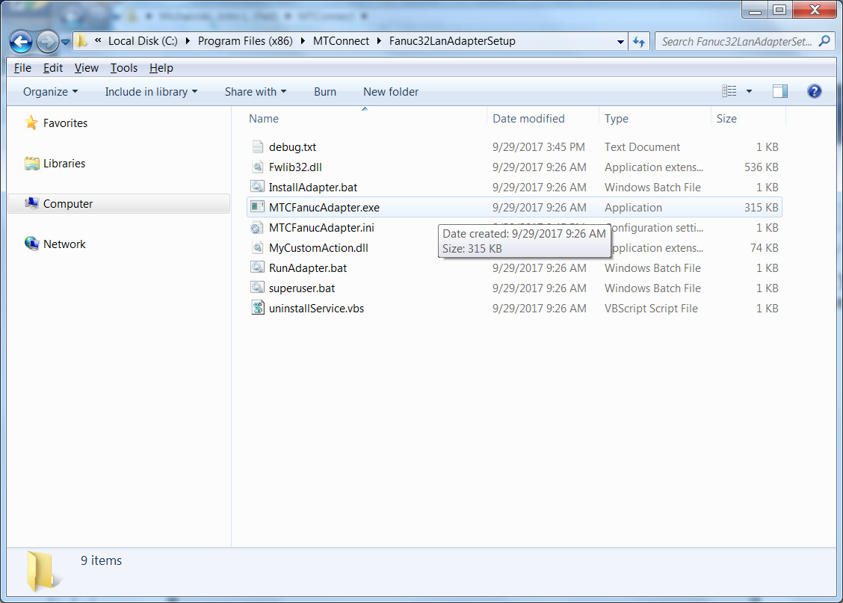

If you see:



Then you cannot use the focas adapter until you get product installed with the DLL

1. Once installed into the windows service control manager (SCM) you need to verify that the MTConnect Adapter has indeed been installed. The software developers only work a little on this, so should NEVER trust them. Open the service: right click manage on the Computer icon. (It will ask for UAC permission by asking for admin user/password on windows 7/8) You should see MTCFanucAdapter, Its state could be manual or automatic, started or stopped. If manual, make automatic. If stopped, start. If not there, you may need to install “by hand” which requires going to

“C:\Program Files (x86)\MTConnect\Fanuc32LanAdapterSetup” and running the batch InstallAdapter.bat which will hopefully install the adapter into the Windows SCM. If not, please contact [john.michaloski@nist.gov](mailto:john.michaloski@nist.gov)

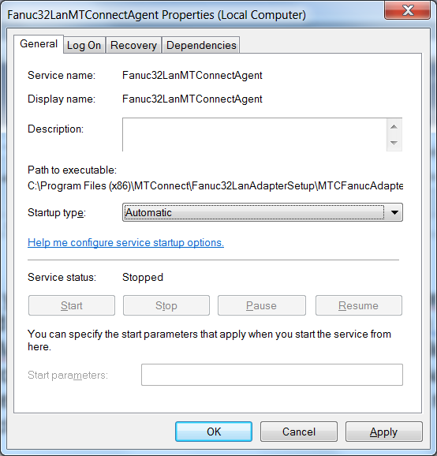

1. Now, you can see the properties of Fanuc32LanMTConnectAgent which should show you the location of the program (exe) in “C:\Program Files (x86)\MTConnect\Fanuc32LanAdapterSetup”. Startup type should be automatic, so that every time you boot the PC, it will start the MTConnect Adapter. It should also give you service status of “Started” with Stop highlighted. If not start the service, please contact [john.michaloski@nist.gov](mailto:john.michaloski@nist.gov)

## UnInstallation Steps

1. Bring up control panel and Programs->Uninstall a program

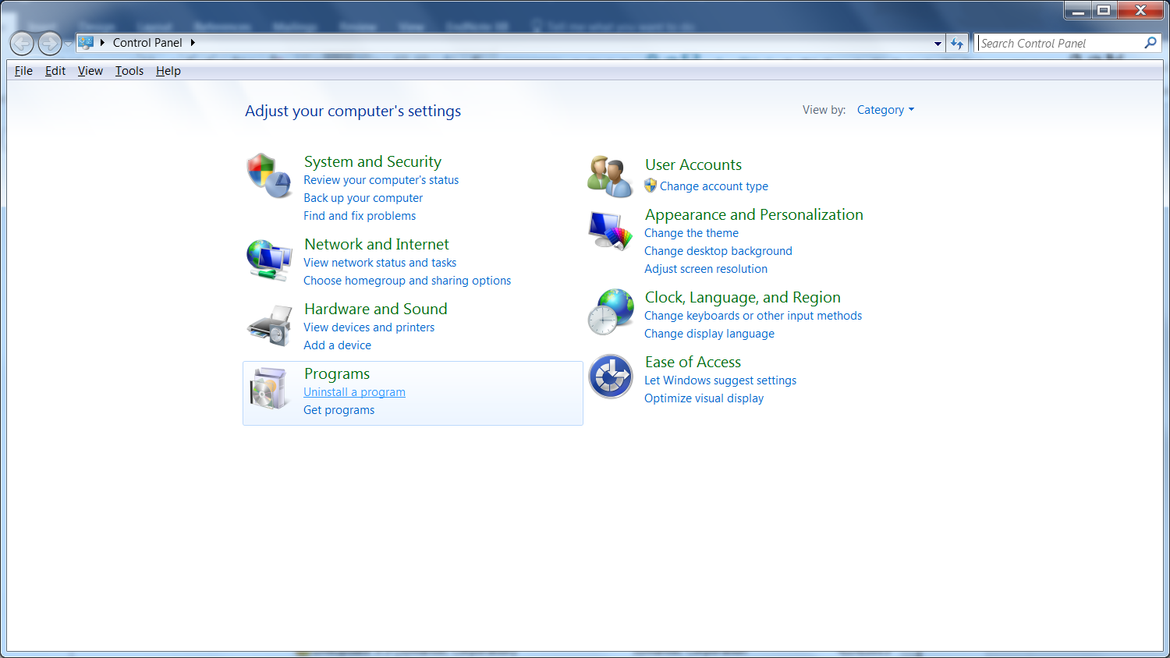

1. Uninstall ***Fanuc32LanAdapterSetup***

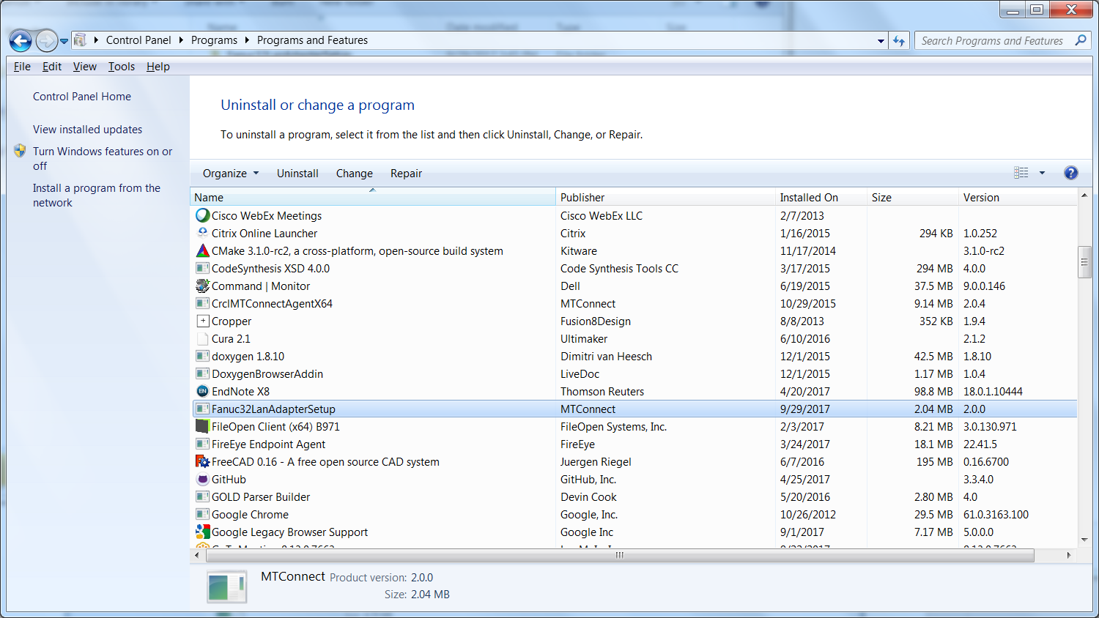

1. Please note, this has to stop and remove a windows service. Often this doesn't work. So you may need to manually go in and stop the service and use the unintallservice.vbs script to remove the service.
2. You will need UAC privileges to allow you to uninstall on window 7 or higher. Otherwise you will get the dreaded permission denied error.

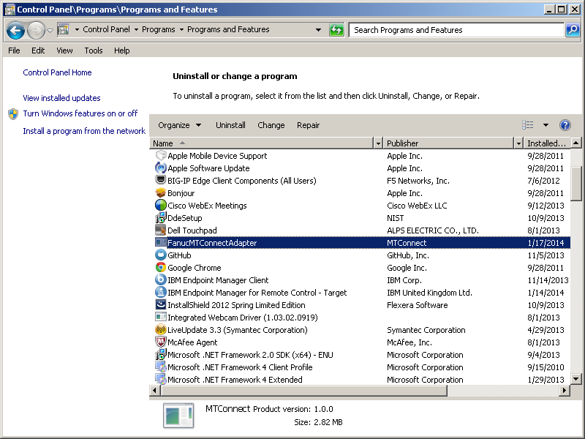

# Followup

Since the Fanuc MTConnect Adapter is a service, and already hand configured (if any configuration) you can navigate to the folder:

C:\Program Files (x86)\MTConnect\FanucInstall

stop the service from the Windows SCM (right click Manage on My Computer and navigate to services, specifically MTCFanucAdapter),

replace the EXE

C:\Program Files (x86)\MTConnect\FanucInstall\MTCFanucAdapter.exe

and then start the service.

## Fanuc Adapter Logic



## Software Architecture

Fanuc LAN Focas library with MTConnect Adapter using Port 7878 to communicate with MTConnect Agent:

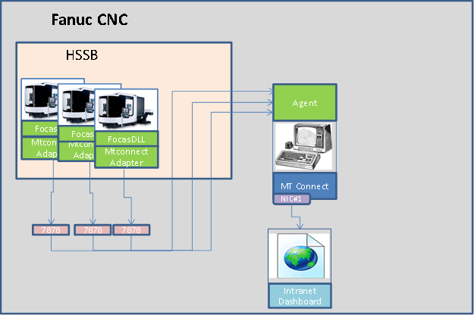

When you look at the MTConnect Adapter telnet output, it will have a prepended “Device name:” to each tag. The Agent looks for the prepended device id: and will strip it out. e.g.,

2014-06-25T13:55:22|DeviceA:controllermode|AUTOMATIC

If you leave the DeviceName blank during setup, the mobile device stuff described above will be ignored.